Summary
2015-10-28
Author: Chris Huntley
West Vancouver, B.C.
This captures the process I used to get IR Remote keyboard codes into my HCA (Home Control Assistant)

Getting a Code File
The website below provides codes for thousands of remotes.
First register for a username and password. Then login.
Under the Database TAB, type the Brand Name and select the product.
Then press the “Send Code Set” button
See below for a typical capture (for my Aios remote)
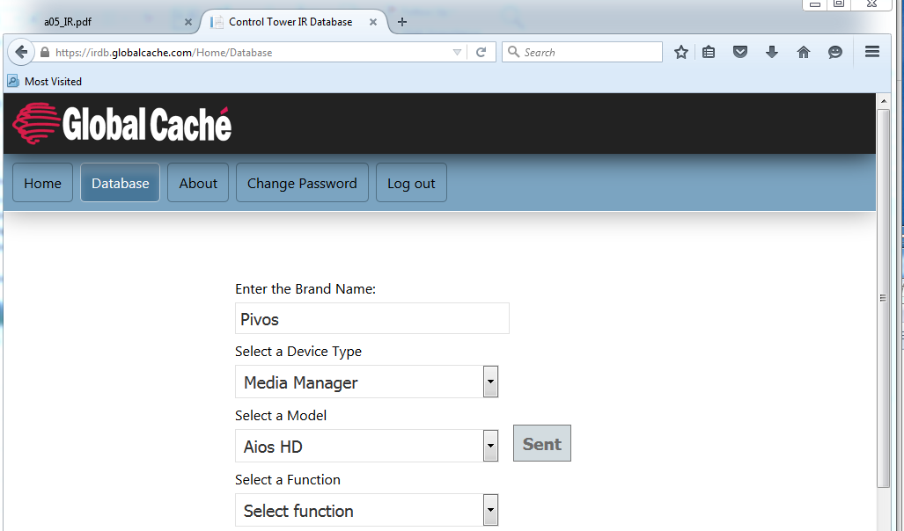

Converting the Code File
Both HEX and GLOBAL CACHE formats download with each codeset.
The first line shows the different sections:
As an example, the downloaded code for a (Pvios/Aios remote) <AUDIO> key comprises:
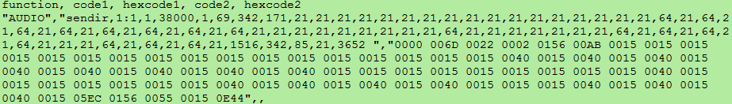
The following steps converted the downloaded files to a format acceptable to HCA.
- Remove the first line (function, through hexcode2)
- For each key, remove everything beyond the last decimal number (from “,” through ,,)

- Change the quotes around the key name to square brackets, so “AUDIO” to [AUDIO]
- Change the immediately-following (delimiter) ,” to the ASCII TAB character 09hex
- For all keys, consider changing the IR port (1:1) to that to be used (e.g. 4:2)
(Not needed for HCA since the HCA application using it requires the port to be configured there.)
For clarity, the above is displayed below in HEX
Note that this shows the TAB character (09), and that each key entry is terminated by CR LF.
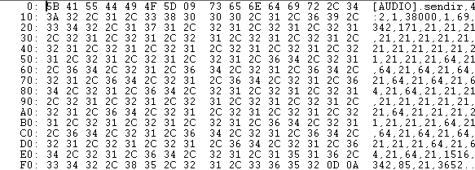

Importing the modified Code File into HCA
In HCA select Interfaces/IR GC-100 Setup/Global Cache Keypads(tab); see:
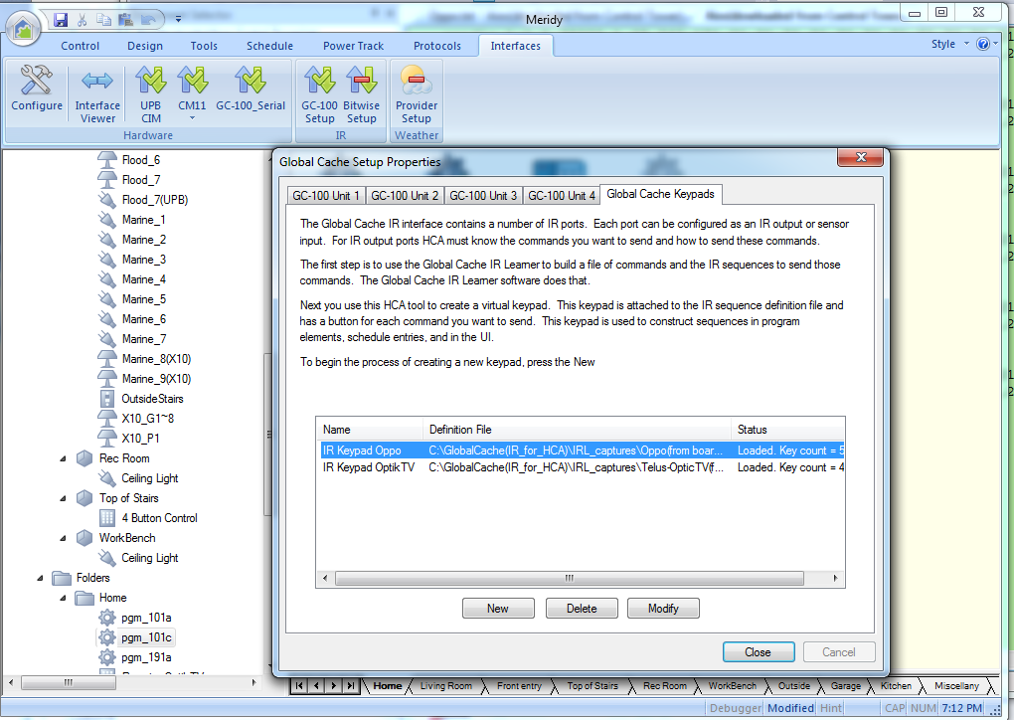
Press <New> and browse for the modified “Definition file”
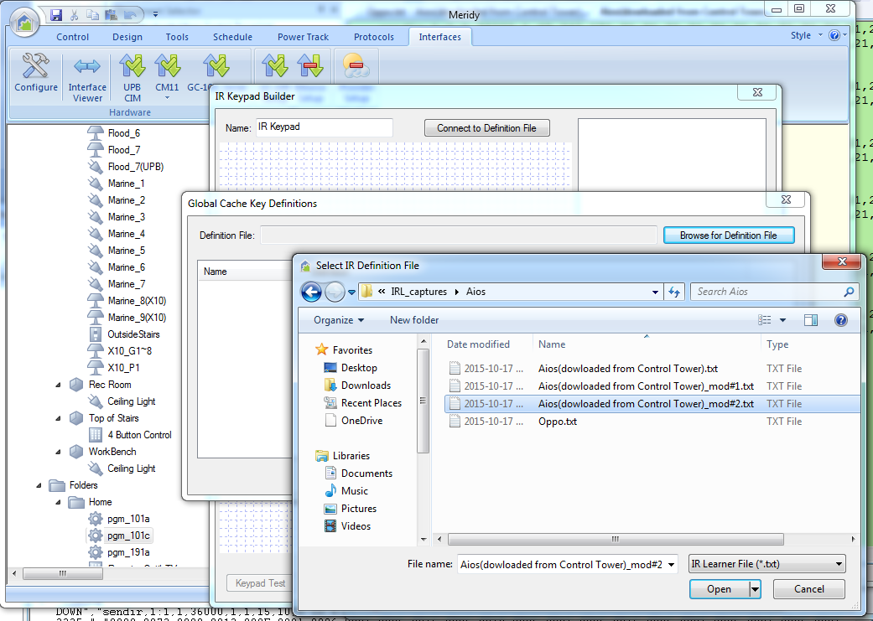
See the Key definitions form is now populated (this means HCA is happy with the file’s format ☺
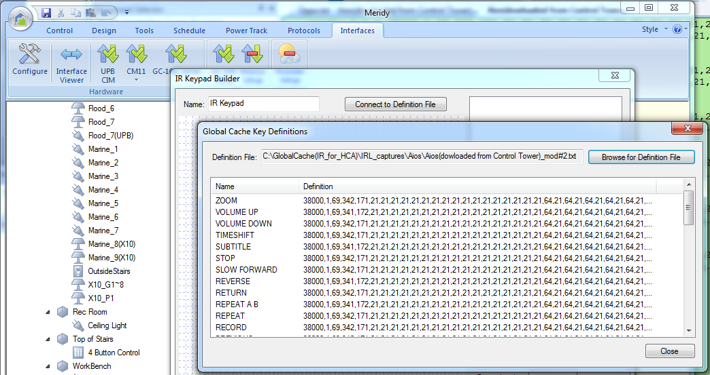

Closing this window, dragging the keys of interest to one’s own GUI; then pressing the <Keypad Test> shows:
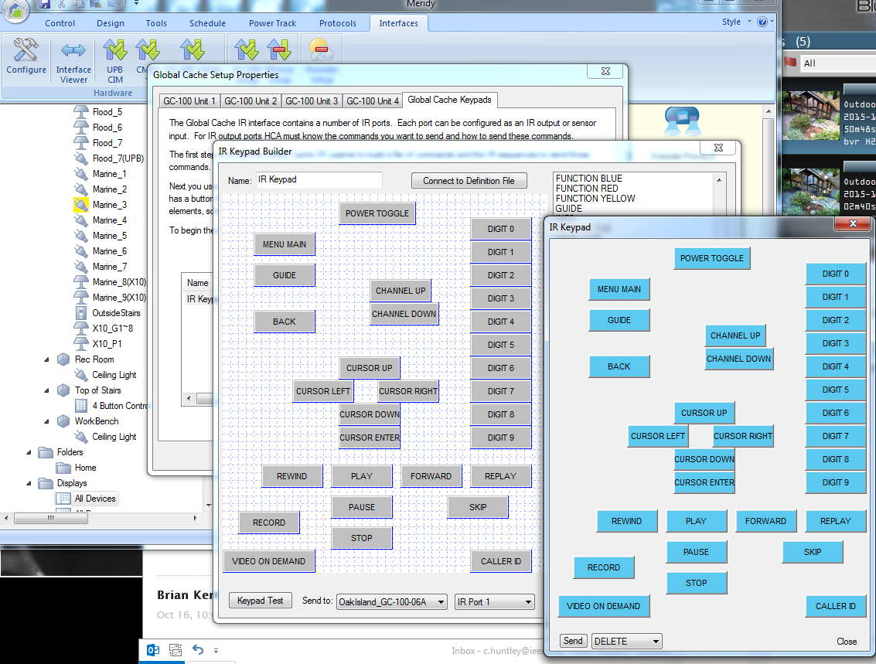

<end>

